WEEK-1

1)

import java.util.*;

public class p1{

public static void main(String[] args){

Scanner sc=new Scanner(System.in);

long x=sc.nextLong();

if(x>=-128 && x<=127)

{

System.out.println("*byte");

}

if(x>=Short.MIN_VALUE && x<=Short.MAX_VALUE)

{

System.out.println("*short");

}

if(x>=Integer.MIN_VALUE && x<=Integer.MAX_VALUE)

{

System.out.println("*int");

}

if(x>=Long.MIN_VALUE && x<=Long.MAX_VALUE)

{

System.out.println("*long");

}

}

}

OUTPUT:

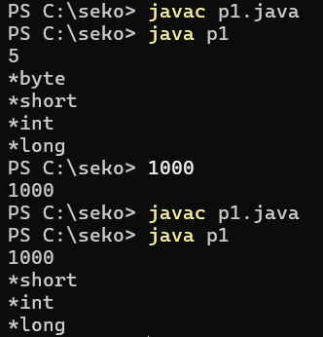

2)

import java.util.*;

public class p2{

public static void main(String [] args){

Scanner sc=new Scanner(System.in);

int n;

n=sc.nextInt();

double c;

c=n/100.0;

System.out.printf("%.2f\n",c);

}

}

OUTPUT:

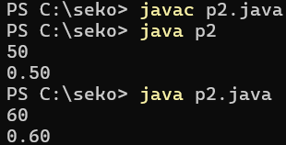

3)

import java.io.*;

import java.util.*;

public class p3{

public static void main(String [] args){

Scanner sc=new Scanner(System.in);

double a=sc.nextDouble();

int b=(int)a;

System.out.println("After type casting:"+b);

}

}

OUTPUT:

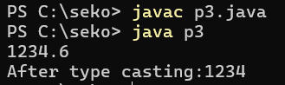

4) import java.util.*;

public class p4{

public static void main(String [] args){

Scanner sc=new Scanner(System.in);

int s=sc.nextInt();

double p=sc.nextDouble();

double k=s*(p/100);

double total=s+k;

System.out.println("New Salary:"+total);

}

}

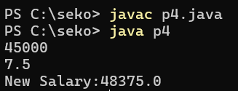

5)

import java.util.*;

public class app{

public static void main(String s[]){

Scanner sc=new Scanner(System.in);

int a=sc.nextInt();

int ori = a;

int rev=0;

int rem,q;

while(a!=0){

rem=a%10;

rev=rev*10+rem;

a=a/10;

}

if(rev==ori){

System.out.print("The reversed number is"+rev+".It is the same as original number.");

}

else{

System.out.print("The reversed number is"+rev+".It is not same as original number.");

}

}

}

OUTPUT:

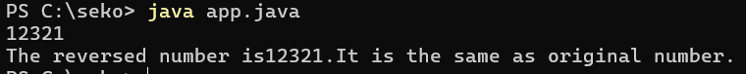

6) import java.util.*;

public class p6{

public static void main(String [] args){

Scanner sc=new Scanner(System.in);

int q=sc.nextInt();

for(int i=0;i<q;i++){

int a=sc.nextInt();

int b=sc.nextInt();

int n=sc.nextInt();

int sum=a;

for(int j=0;j<n;j++){

sum=sum+(int)Math.pow(2,j)*b;

System.out.print(sum+" ");

}

}

}

}

OUTPUT:

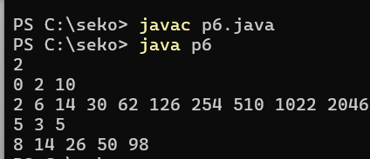

8)

import java.util.Scanner;

import java.io.*;

public class pg2

{

public static void main(String[] args){

Scanner scan=new Scanner(System.in);

int n=scan.nextInt();

for(int i=1;i<=n;i++){

for(int j=n;j>i;j--){

System.out.print(" ");

}

for(int k=1;k<=(2*i-1);k++){

System.out.print("*");

}

System.out.println();

}

for(int i=n-1;i>=1;i--){

for(int j=n;j>i;j--){

System.out.print(" ");

}

for(int k=1;k<=(2*i-1);k++){

System.out.print("*");

}

System.out.println();

}

}

}

OUTPUT:

